**Similarity between San Francisco and Los Angeles**

* The Battle of Neighborhoods

Yujin Cho

May 3rd, 2021

1. **Introduction**

San Francisco (SF) and Los Angeles (LA) are two culturally diverse cities in California, United States. In SF, 34 percent of the population is Asian and 15 percent is Latinos. Similarly, in LA, half of the population is Latino and 11 percent is Asian. In addition, these two cities are also popular tourist spots. Before the pandemic, Los Angeles had about 50 million visitors and San Francisco had about 26 million visitors in one year from all over the world.

Among various ways of gauging the cultural diversity in a city, I focus on ***foods***. Foods are usually the first thing people get familiar with when they experience a new culture. Moreover, often people from the same culture form a small town, such as Koreatown, Little Tokyo, Little Italy, or China town.

In this project, *Similarity between San Francisco and Los Angeles*, I compare the categories of the restaurants in SF and LA and understand the similarities and dissimilarities between them.

This analysis would be helpful **to understand the cultural diversity, visitors who would like to explore different cultural foods, and people who would like to start their business**.

1. **Data**
   1. Data Source

For both cities, I first made the list of the neighborhoods; SF from Wikipedia (<https://en.wikipedia.org/wiki/List_of_neighborhoods_in_San_Francisco>) and LA from a website (<http://www.laalmanac.com/cities/ci93.php>). I used each neighborhood’s location to pull the data from FourSquare. I limited the number of venues to 100 per neighborhood within a 500 m radius.

* 1. Data Cleaning

When the data is initially downloaded, it contains various venue categories. To focus on foods, I only selected venues that contain ‘restaurant’ in the venue category. This excludes coffee shops or bakeries, which are not in my interest in this project. A limitation of this filter will be discussed later.

After that, I found that some of the venue categories are too specific. For example, ‘sushi restaurant’ or ‘nabe restaurant’ can be all categorized as ‘Japanese restaurant’. Hence, I reassigned those specific categories to a bigger category by their countries. After this cleaning process, there are over 30 categories left.

Some of the resulting categories are ‘Asian restaurant’ or ‘Mediterranean restaurant’. These cannot fall in one category based on their country, because the ‘Asian restaurant’ may sell Asian foods from several Asian countries. In addition, it is hard to see the trends when there are too many categories with only one or two restaurants in each of them. To resolve this, I assigned another category based on their regions: South Asia, East Asia, West Asia, North America, Latin America, South Europe, West Europe, North Europe, East Europe, and East Africa. I use these labels in further analysis.

1. **Methodology**
   1. Folium map

I used a folium map to display the location of the restaurants individually. There are 200-300 restaurants but the restaurants were not fully displayed in the basic folium map. Therefore, I used marker clusters. After the data analysis, the folium map was used again to display the location of the clusters. This helps to visualize whether the neighborhoods are geographically close to each other or spread out.

* 1. K-Means

To find the similarities between the neighborhoods, I used K-Means. The number of clusters is 5. I labeled each neighborhood with this cluster number.

* 1. Bar graph

After K-Means, I use bar graphs to see the property of each cluster. Bar graphs are useful to display which category of the foods are the most popular and therefore, understand the property of the categories more intuitively.

* 1. Statistics

Statistical analysis was used when comparing the data in SF and LA. There are 584 restaurants in total in LA, while only 341 in SF. This is because the geographical size of the two cities is vastly different, as well as the population. Therefore, it is hard to compare the numbers directly. For this, I normalized the data to the total number of restaurants in each category. After that, I rearranged the table to display the top five popular venue categories in the two cities.

1. **Data Analysis and Results**
   1. San Francisco
      1. Display the venues

First, I pulled the list of venues from Foursquare with the location of the neighborhoods. There are 1383 venues in total and I left only the venues that contain ‘restaurant’, as explained earlier.

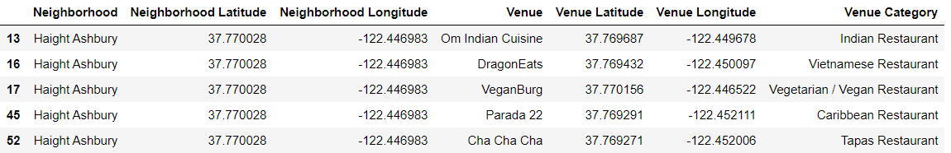

As seen in this table, I have information about the location (latitude/longitude), the name of the venues, and the category in each neighborhood.

When I plot the location with a folium map, here is how it looks like:

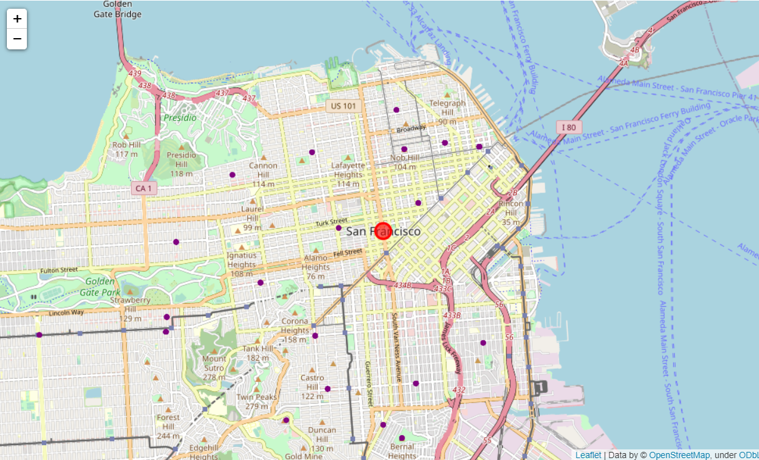

The purple dots indicate the restaurants and the red dot is the center of SF. Even though there are about 340 restaurants, only a few of them were displayed. This could be due to some restaurants are too close to each other in this zoom scale 13. To overcome this, I used marker clusters, instead.

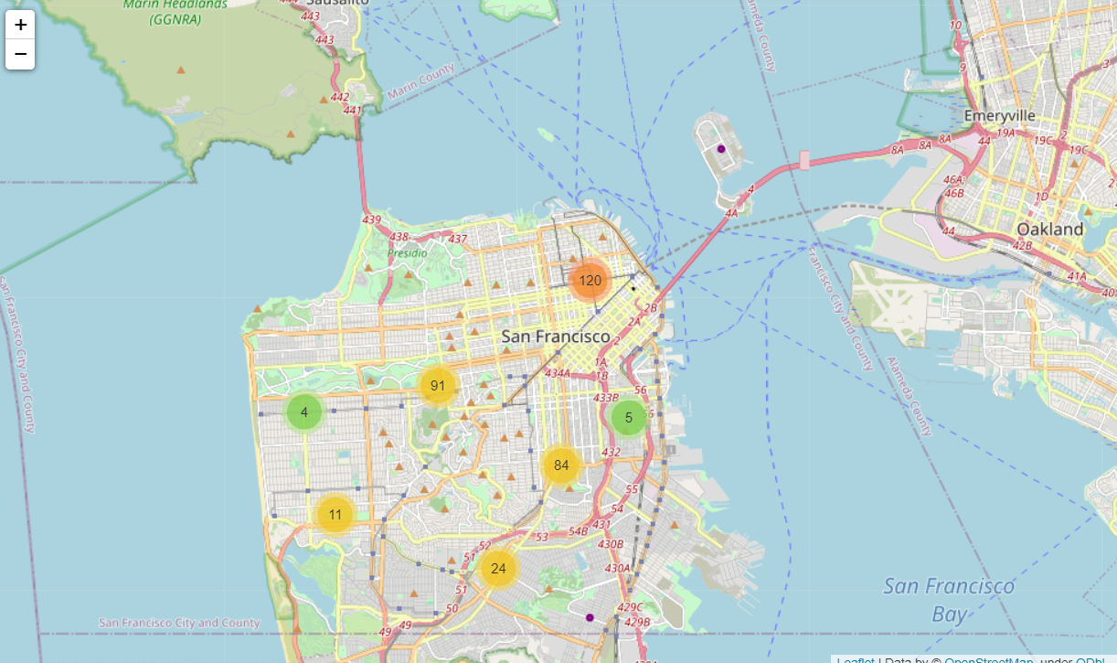

Instead of dropping a dot, it shows how many of them are in the area. When clicking the number, it zooms in the area and returns a subset of the dots. For example, here is how it looks when clicking the orange circle with 120.

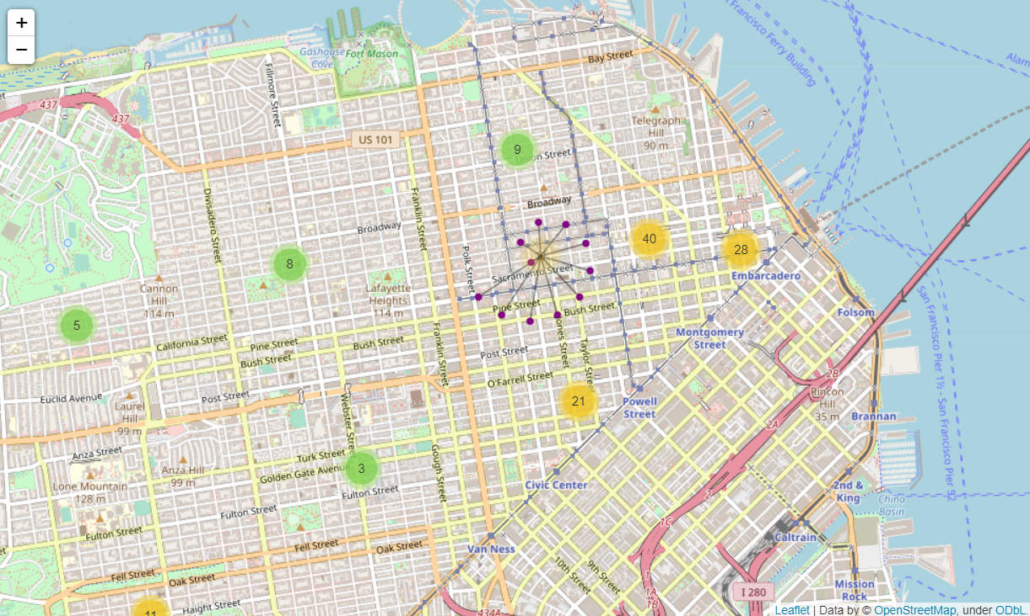

When the subset is selected, the purple dots show up, indicating the location of the restaurants.

* + 1. Assign categories to the venues

As explained in the Data section, I reassigned some of the specific categories based on their origins and also assigned the region. The resulting data frame looks like this:

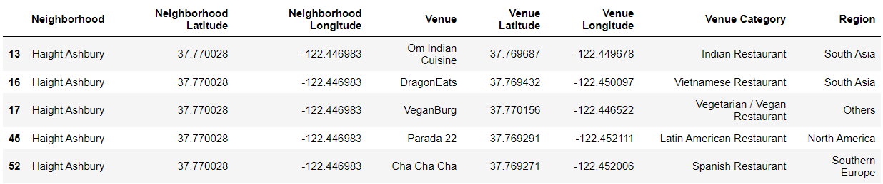

The last column, ‘Region’, is the one I assigned based on the continent. Then I counted how many restaurants there are in each neighborhood based on the region.

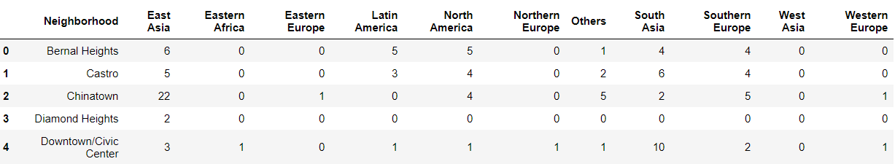

For example, in Bernal Heights, there are 6 East Asian restaurants while there are 22 in Chinatown. This makes sense because it is Chinatown. It also has four North American restaurants.

* + 1. K-Means Clustering

K-means clustering is a good tool to see the similarity between the neighborhoods. This method will find similar neighborhoods based on the distribution of the restaurants. Here, I used five clusters and assign the cluster labels to each neighborhood, as shown in the second column in the data frame below.

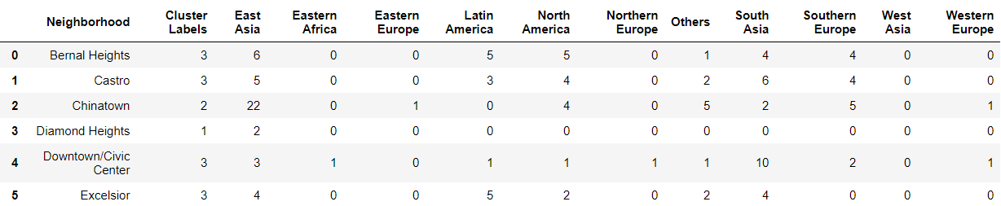

* + 1. Explore the clusters

Now let’s look at each cluster. This is Cluster 0.

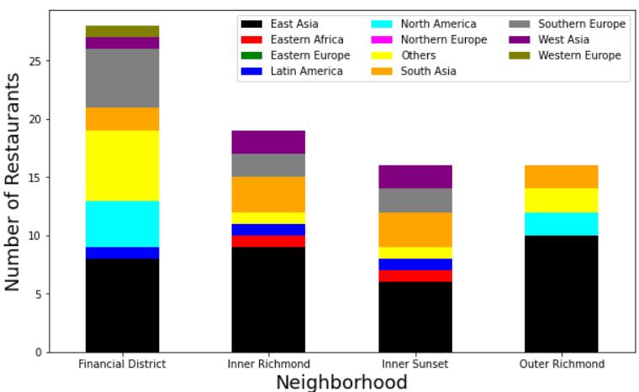

As you can see, there are many East Asian foods and South Asian foods are the second popular foods in this cluster. The ‘Others’ category is also comparable to South Asian foods.

Cluster 1 has the most neighborhoods among the five clusters. Instead of having one dominant category, it has many East Asian, South Asian, North American, and South European restaurants. This cluster is more balanced than Cluster 0, which has dominant East Asian restaurants.

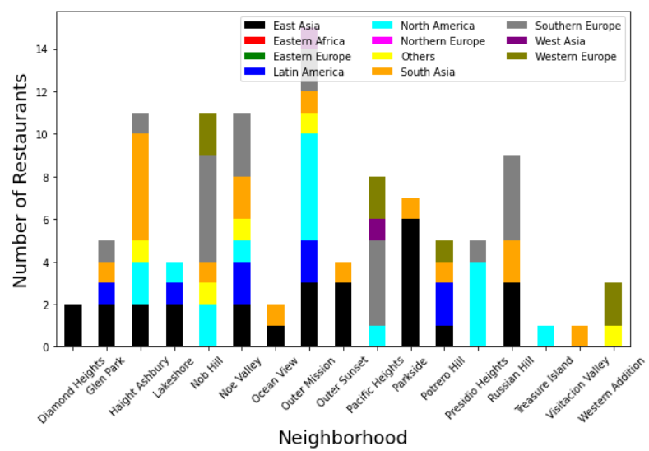

Likewise, we can do the same analysis for the remaining clusters. In Cluster2,

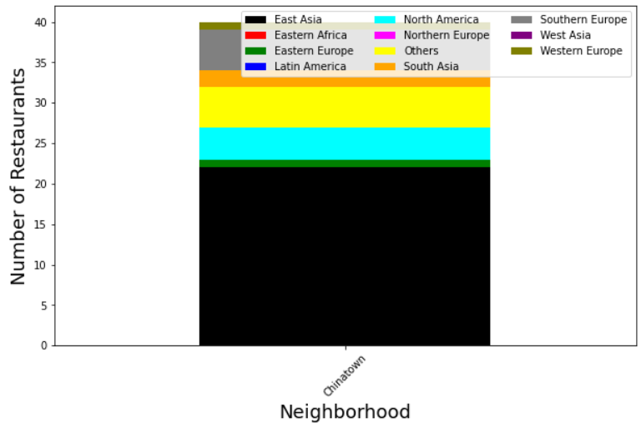

This Cluster has only one neighborhood, Chinatown. The difference between this and Cluster0 is that this cluster has a much higher proportion of East-Asian restaurants than the other categories. It also has a few East European restaurants.

Cluster 3 is below:

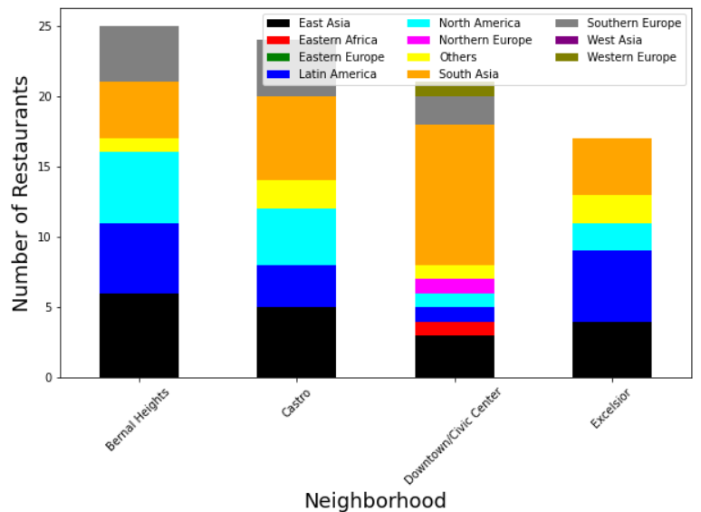

This is a cluster of neighborhoods that have more South Asian (orange) restaurants in the area. There are also many East Asian restaurants as well. The largest difference from the other categories is that Latin American restaurants are also quite significant.

The last Cluster 4 looks like this:

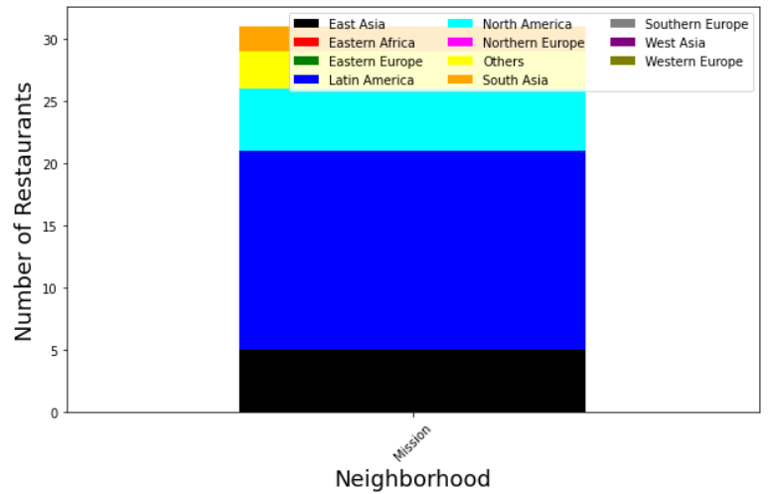

It has only one neighborhood and Latin American foods are the most popular ones here. Compared to Cluster3, this cluster has much fewer South Asian restaurants.

* + 1. Visualize with folium map

With the bar graphs, it is easy to understand the properties of each cluster and the neighborhood. However, it is hard to see where they are geographically located unless you are very familiar with the names of the neighborhoods. To assist this, I used a folium map.

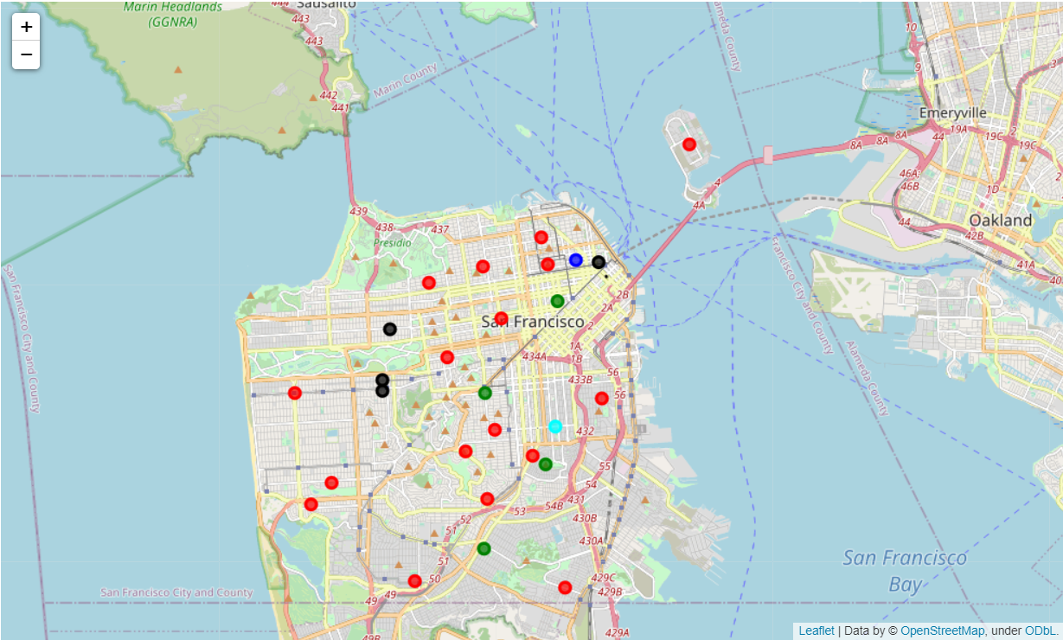

Here, different colors of the dots indicate different clusters. Cluster 0 is Black, Cluster 1 is Red, Cluster 2 is Blue, Cluster 3 is Green, and Cluster 4 is Cyan. As you can see on the map, the neighborhoods in Cluster 2 are evenly distributed in SF, which has the most East Asian restaurants. The blue dot, Cluster2, is Chinatown, as expected. Cluster 4, which has the most Latin American foods, is the Mission district, which is the center of Mexican culture.

* 1. Los Angeles

I repeated the same analysis for LA. LA city is much larger than SF and there are a lot more neighborhoods.

* + 1. Display the venues with the folium map and Data cleaning

I applied the same data cleaning method as done in the SF data – select only the venues that contain a string ‘restaurant’ in the category, reassigned the category if they are too specific, and assigned the region.

The individual restaurants can be plotted with a folium map using the marker clusters.

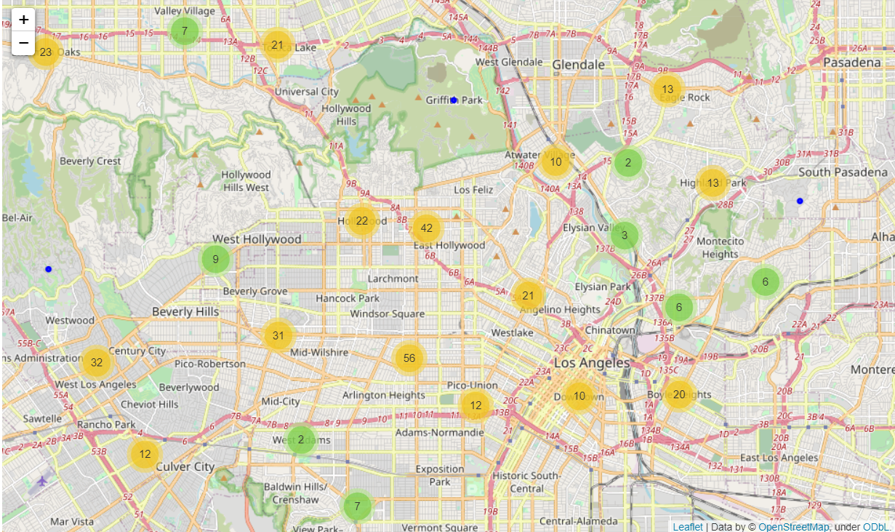

The map below is the zoom-in image of the map above when clicking the circle and see the details of the restaurants.

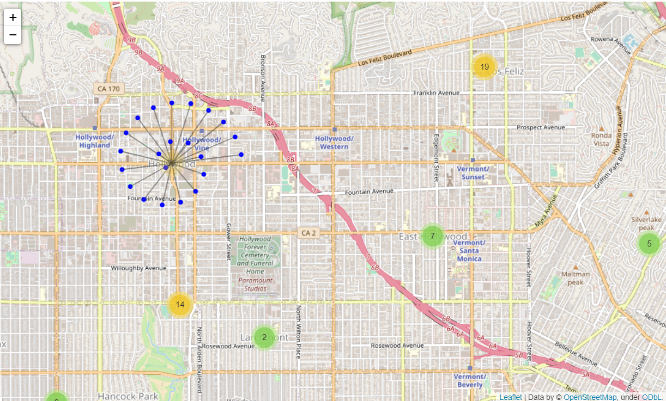

After the data cleaning process, the data frame looks like this:

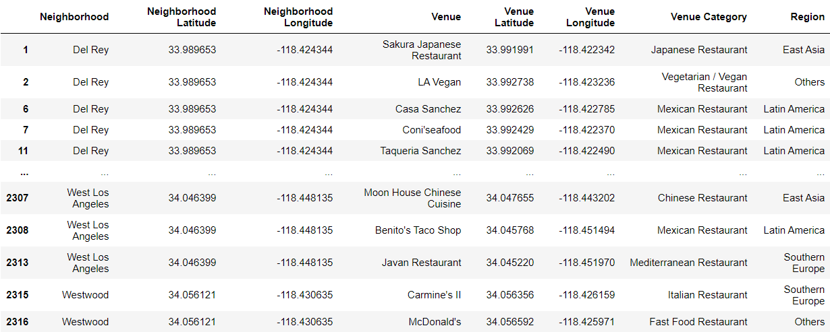

Now it has one more column, Region. I also counted how many restaurants each neighborhood has.

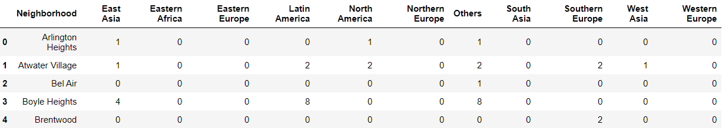

* + 1. K-Means clustering

To explore the similarities of the neighborhoods, I used K-means, as in the SF data analysis. The number of clusters was 5 and I assigned the cluster labels to the data frame.

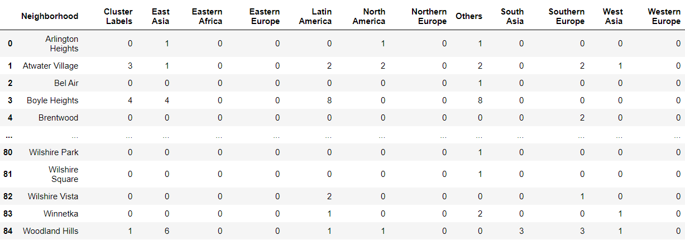

Now let’s take a look at each cluster. Cluster 0 has the most neighborhoods.

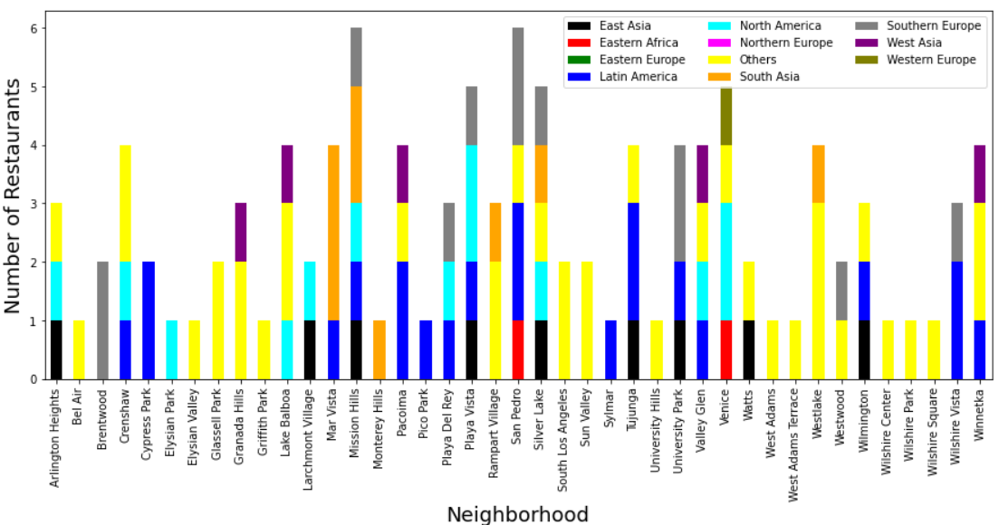

This cluster is a collection of neighborhoods that have most of the restaurants in the ‘Others’ category and Latin American foods. Others include fast food, seafood, and vegan restaurants.

Cluster 1 has more Asian foods, both East and South, represented by black and orange colors, respectively.

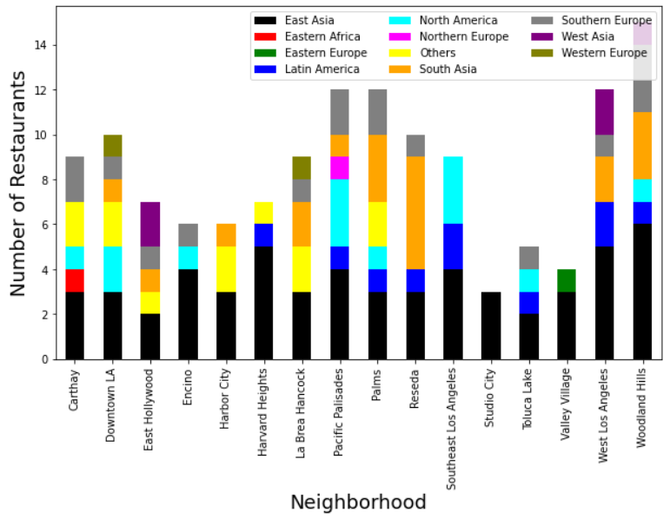

Cluster 2 is mainly dominated by East Asian foods.

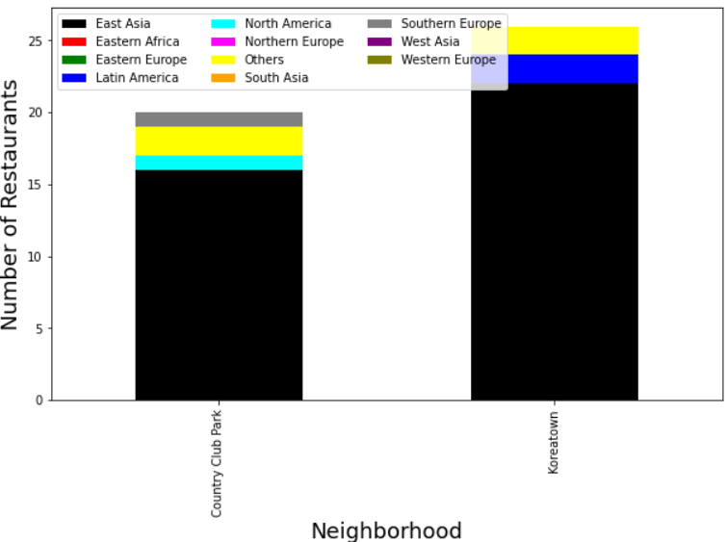

Cluster 3 has more Latin American foods:

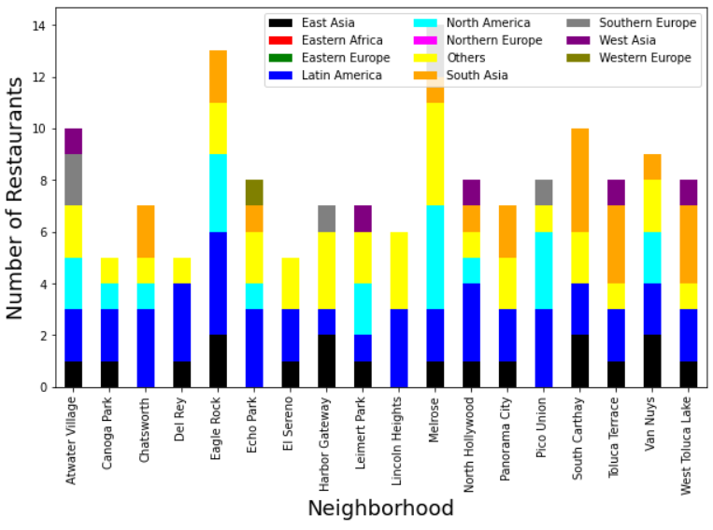

It is similar to Cluster4:

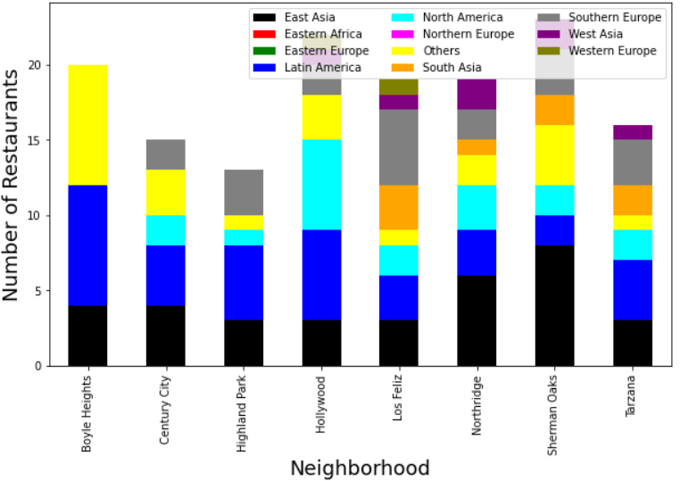

The difference between Cluster3 and Cluster4 is the second popular food in Cluster 4 is East Asian foods while in Cluster3, others and North American foods are more popular.

* + 1. Visualize the clusters with a folium map

I used a folium map to see how the neighborhoods and the clusters are geographically distributed. Black, red, blue, green, and cyan color indicate Cluster 0-4, respectively. As you can see, the black dots are distributed throughout the cities, which has the most restaurants in the Others category. The most popular foods in neighborhoods in Cluster 1 are East Asians and they are distributed around the touristy area, such as Downtown or Hollywood. The neighborhoods, Country Club Park and Koreatown, in blue dots have the dominant East Asian foods. Cluster 3 and 4, where Latin American foods are the most popular, are also distributed across the city.

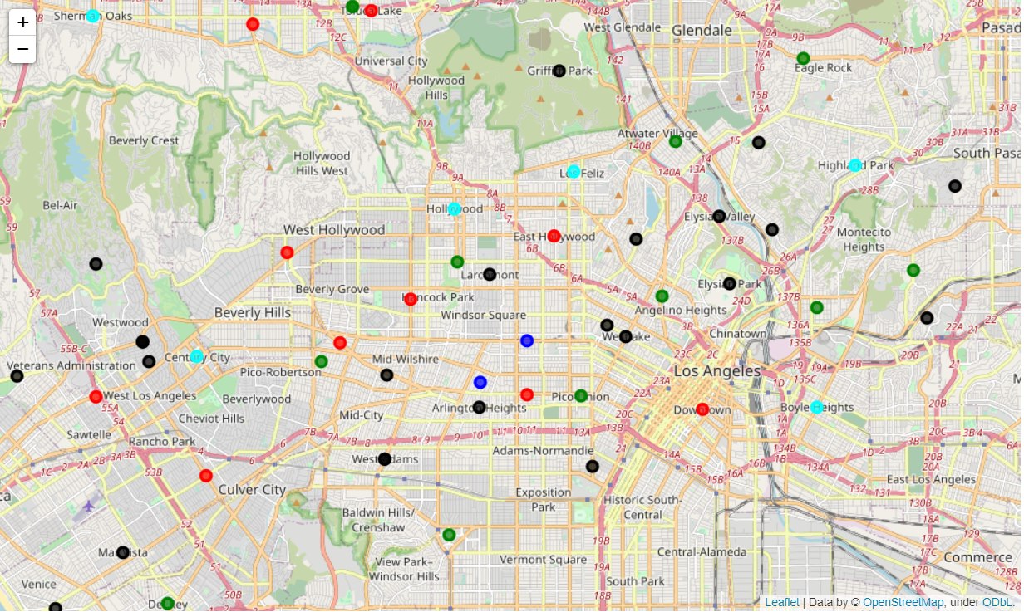

* 1. Comparison between San Francisco and Los Angeles

To compare the two cities, I analyzed each cluster in the two cities.

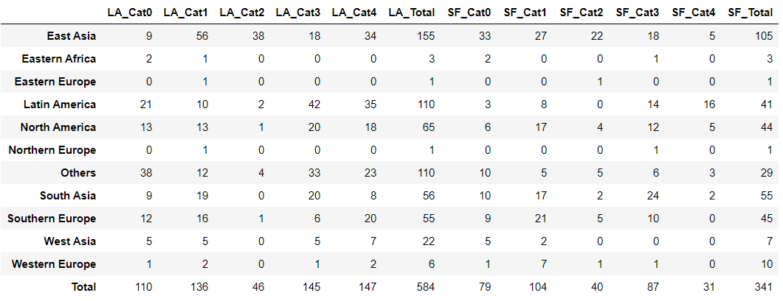

This table shows the total number of restaurants in each regional category in the clusters. LA_Total and SF_Total are the total number of restaurants in the entire LA and SF, respectively. The number of restaurants in LA is about 1.7 times more than that in SF, so to compare it better, I used percentage.

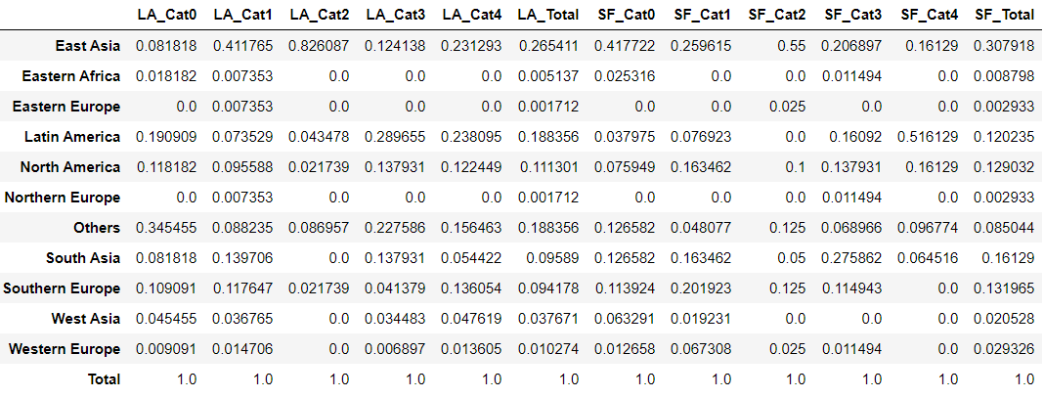

However, this is also not very easy to look at it at a glance. Based on this data, I picked the top five regional categories in each cluster.

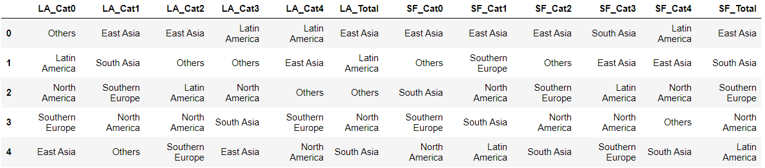

Now this table is much easier to look at. In LA and SF, East Asian foods are the most popular foods, while the second most popular food in LA is Latin American foods and South Asian foods in SF. I will further discuss the results in the next section.

1. **Discussion**

In LA, the most popular food is Asians, and the second most popular ones are Latin American restaurants. In SF, Asian foods, both East and South, are the most popular. This could be related to the cultural diversity in the two cities. As mentioned in the Introduction section, Asian and Latin American population is high in the two cities, compared to the rest of the cities in the States.

In addition, in SF, the neighborhoods, whose popular foods are Asians, are distributed uniformly throughout the city. This can be explained by the high Asian population (~34%) in SF. In LA, Latin American restaurants and East Asian restaurants are also distributed homogeneously but other types of foods are more popular, such as fast food, seafood, vegan restaurants, etc. that could not be culturally categorized.

Though this analysis gives us a good insight, there are a couple of points that we need to remember when understanding this analysis.

First, I filtered the venue categories with the search criteria 'restaurant' to exclude coffee shops or bakeries. However, there could be some restaurants whose category does not have the word 'restaurant', such as 'Poke Place' in SF. Poke is Japanese food, but its category is 'Poke Place'. Due to the large volume of the data, it was difficult to fix it by hand and it was only a few restaurants, compared to the total number of restaurants in each city. Therefore, this would be a minor problem, but something that we can keep in mind. To resolve this issue, we can manually check and include them in the data frame.

Second, there is the 'Fast Food' category. This is included in the 'Others' region since it is hard to define which region it belongs to. The 'Others’ region also includes 'Vegan restaurants' or 'Seafood restaurants'. These could have been categorized as American foods, but it was hard to know which foods they are selling. To resolve this issue, we can pull menu data from Foursquare and add them to the right category.

1. **Conclusion**

In LA, there are more Latin American foods in Cluster3, west of downtown LA. Eastern Asian foods are popular in downtown areas where Korean town and Chinese town are, and near the Hollywood area. Cluster0, the black dots in the map, are distributed evenly throughout the entire LA area. In Cluster0, 'Others' is the most popular category. As mentioned in the Discussion section, this 'Others' category includes a lot of restaurants that are hard to find one category.

In SF, the distribution is quite interesting. Eastern Asian foods are the most popular in three clusters, Cluster0-2. In the map, they are distributed evenly throughout the entire area. The second popular category is 'Others', which most likely includes fast-food restaurants. Latin American food, as shown in Cluster3 in SF, is the most popular in the Mission district in SF, which is the center of Mexican culture.

Overall, restaurants in LA and SF are very diverse in culture, as expected from the population. Eastern Asian foods, Latin American, and North American foods are the most popular in the two cities. The difference is those cultural foods are more concentrated in certain neighborhoods in LA, while they are homogenously distributed in SF.

This analysis would be helpful if one wants to get cultural food for their lunch or dinner. It would also be helpful for tourists who want to try diverse foods, rather than targeting one specific restaurant. People who would like to start their business could also take advantage of it. For example, a neighborhood, that has a lot of East Asian restaurants, is Chinatown and Koreatown. If someone wants to start a business related to those culture, they can open one there based on this analysis.